**Power BI**

**Assignment 4**

1. **Make a simple dashboard and show columns, bar charts, line charts, and area**

**charts.**

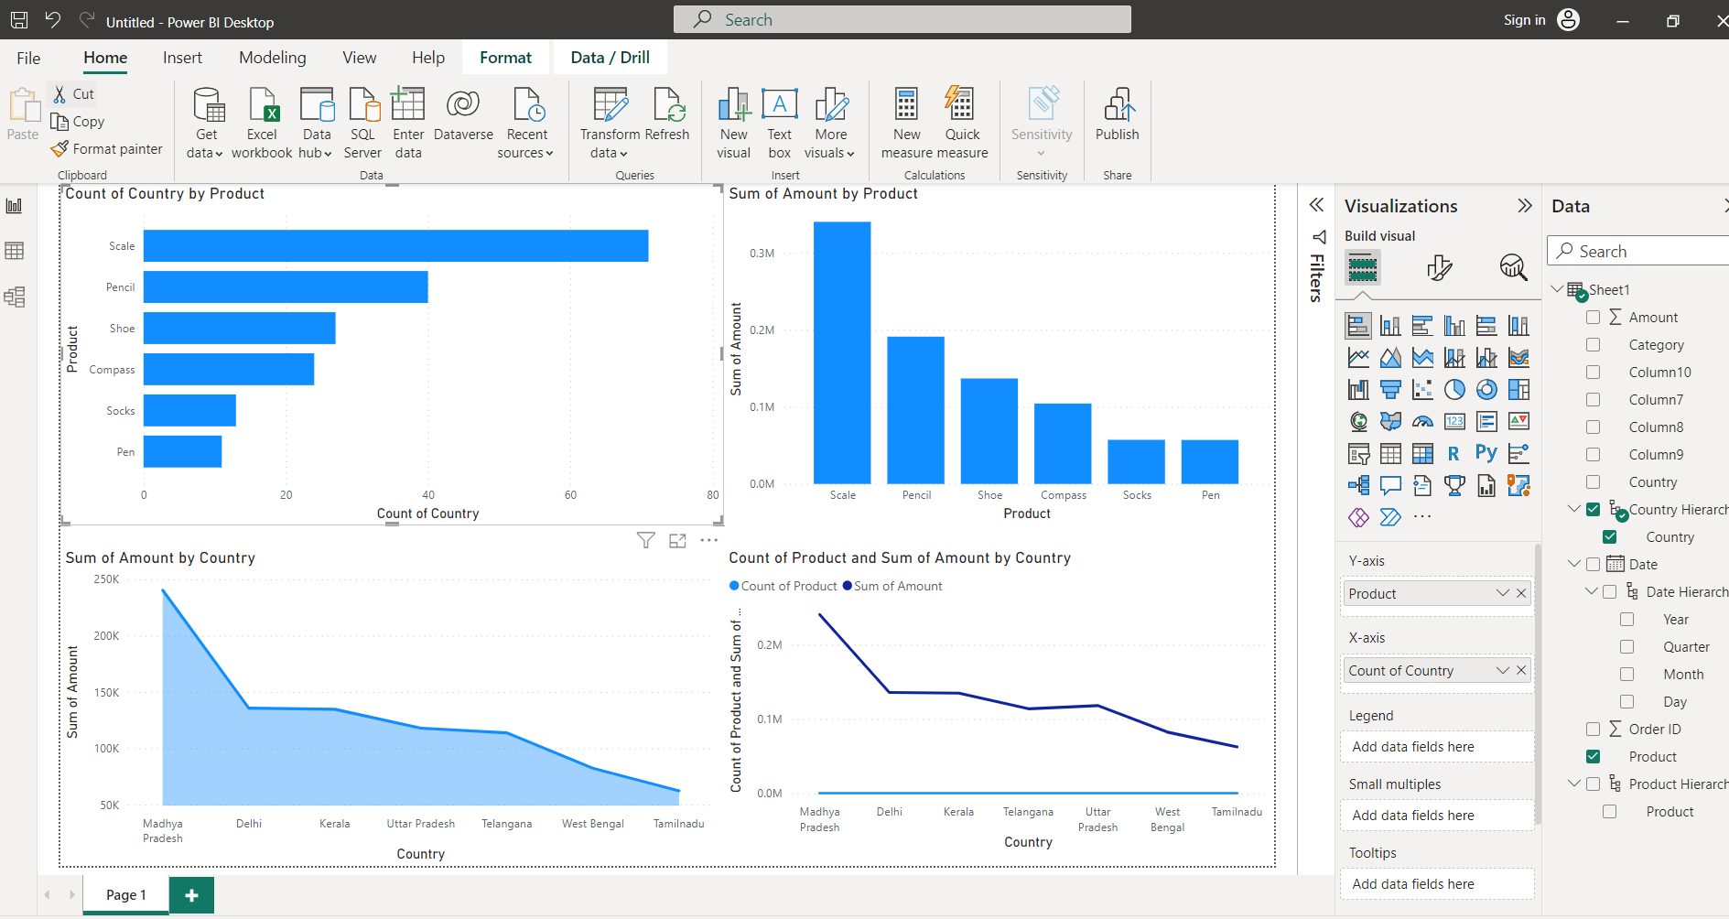

**2. Make a simple dashboard and show combination chart, Scatter chart, Shape**

**chart, and Treemap chart**

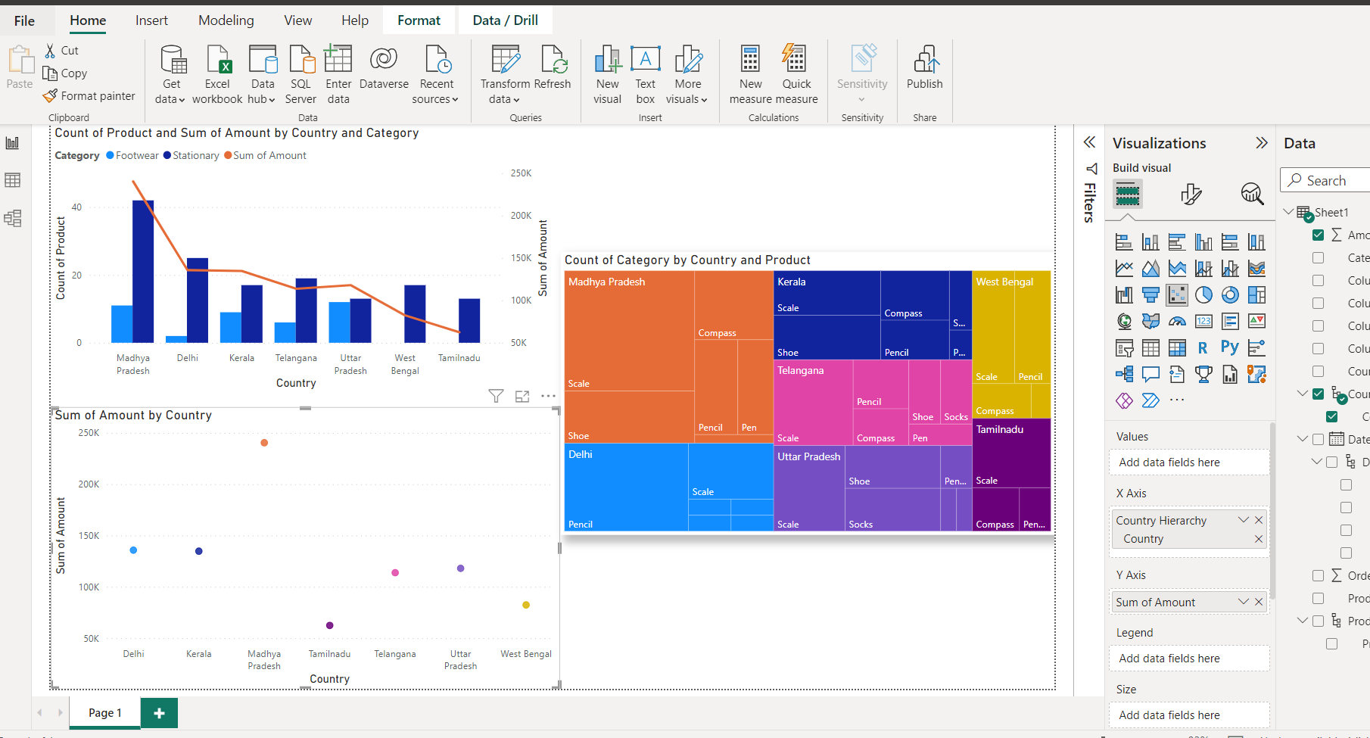

1. **Make a dashboard and show 2 maps visualization i.e. basic map and filler maps**

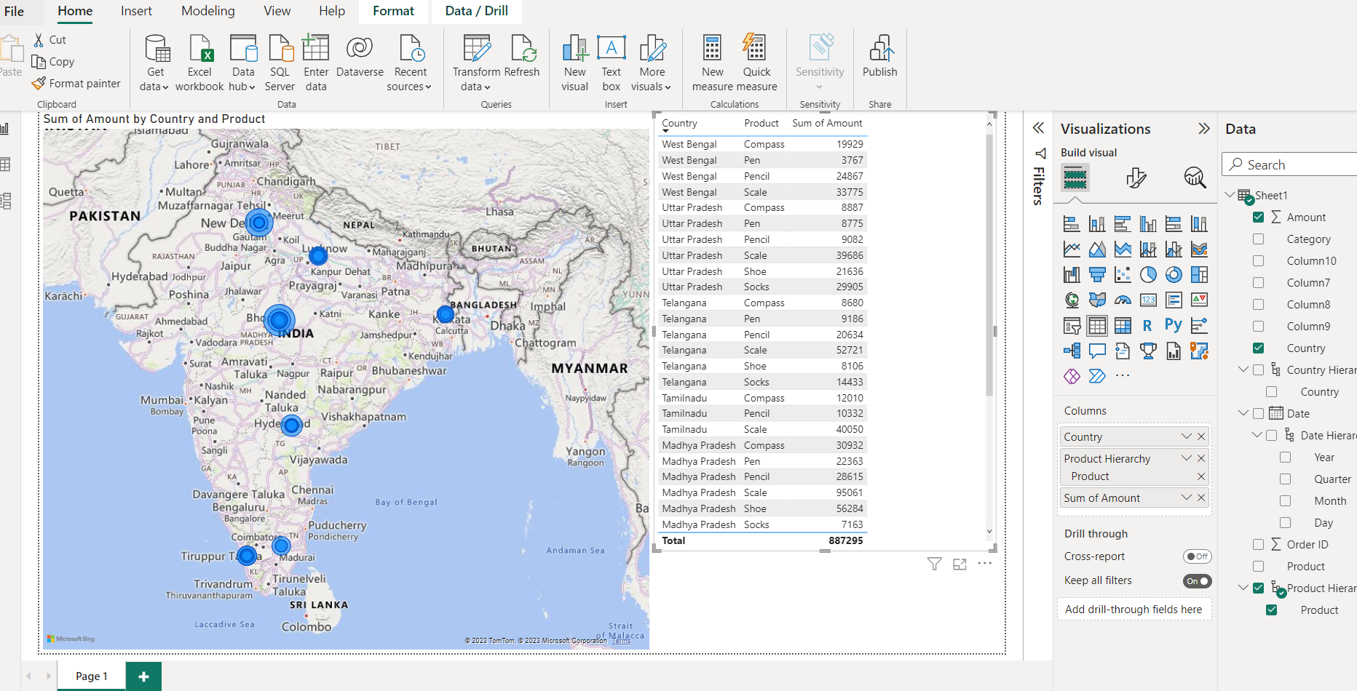

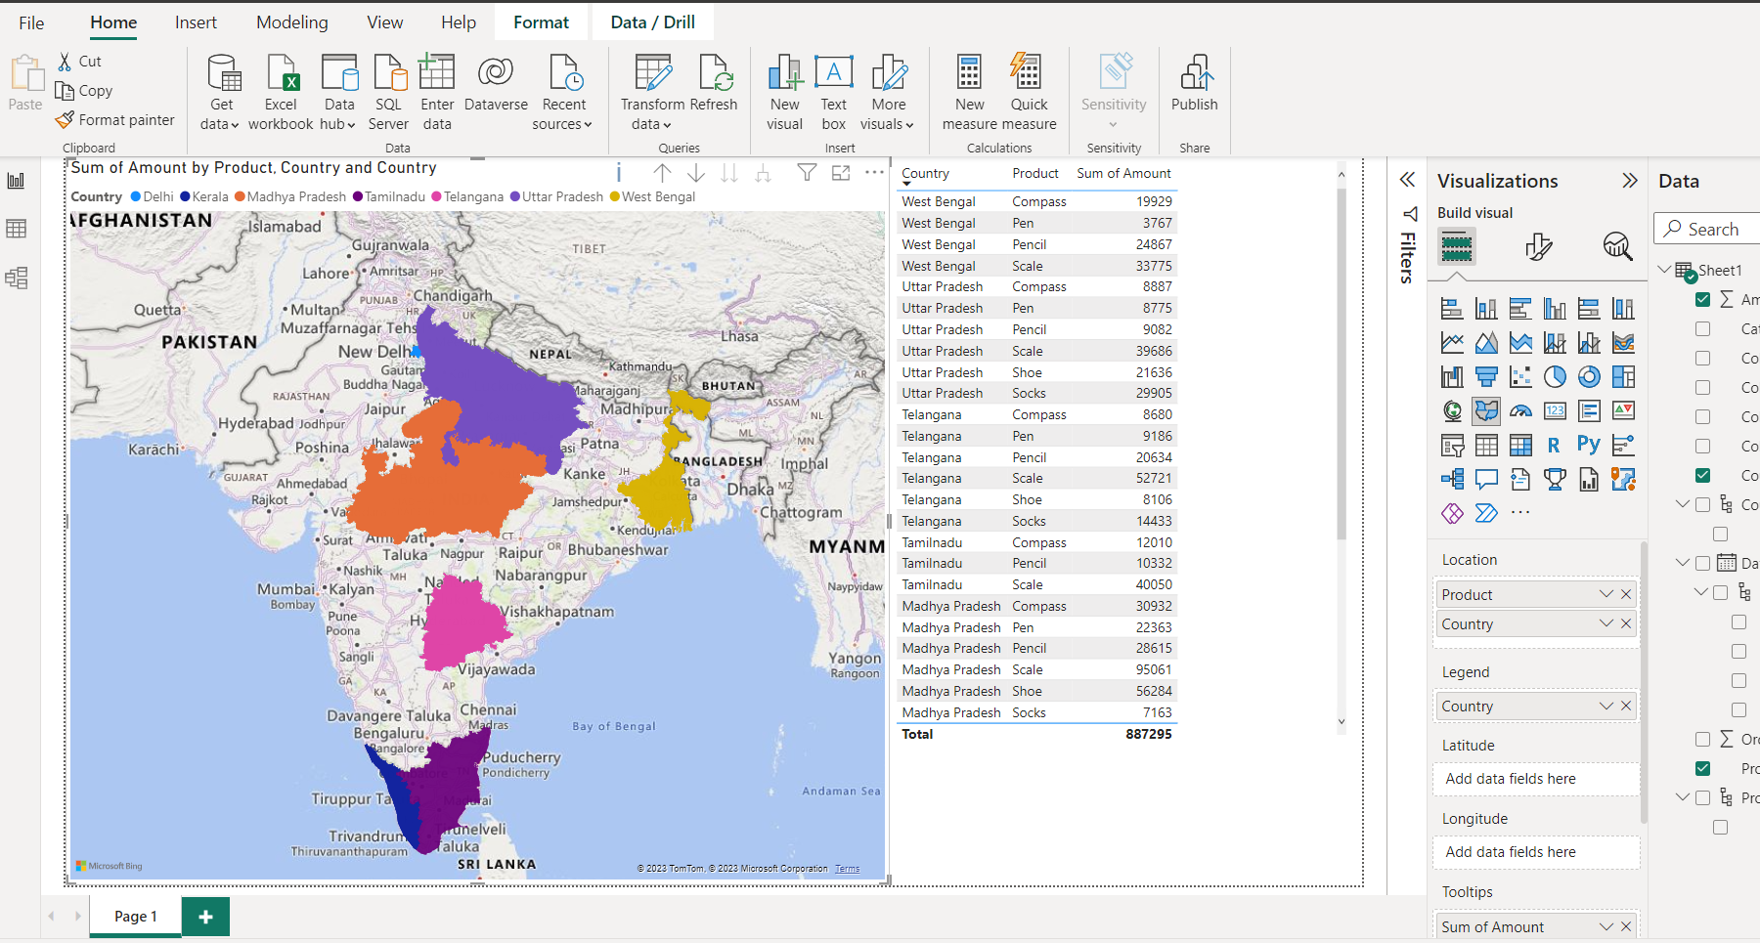

**4. Create a report which has:**

**Bar chart**

**Card visualizations**

**Combo chart visualizations**

**Matrix visualizations**

**Column chart visualizations**

**guide: Sales data can be used**

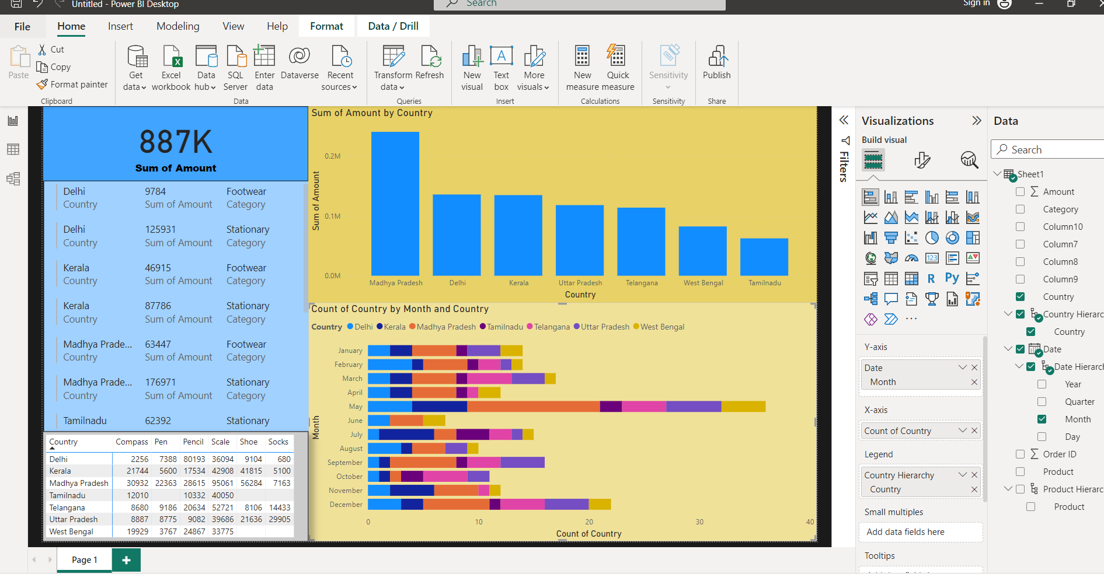

1. **Make a report to analyze product sales using treemap visualization**

